SSAP Green Event Guide
Your organization plays a pivotal role in leading sustainability on campus.
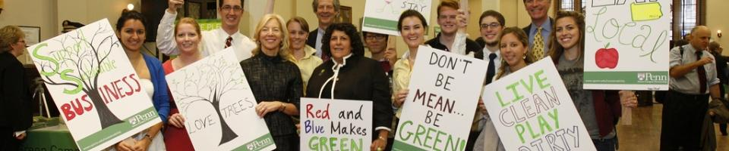

Please refer to the resources below to make your event more sustainable! Reducing your organization's footprint and introducing constituents to sustainable behavior will go a long way towards making Penn a more environmentally conscious campus. So, Thank you for using this guide!!

Ordering Food
Food is a great way to build community (and ensure attendance) at events. However, supplying food can be a wasteful process. A few simple changes in how you supply food for your events can go a long way in making your organization more sustainable.
What food to order (+)
- Vegetarian or vegan food! → Reducing meat consumption is one of the easiest ways to reduce your environmental impact. If you need meat at your event, try to provide a good vegan/vegetarian option. Also, there are plenty of veg options so tasty no one will even notice there isn’t meat.
- Food which you can eat without utensils! → This cuts down a waste a lot and makes clean up a lot easier.
Where to order food from (+)
Some suggested places:

Main Courses

- Hummus Grill, Walnut St - Vegan options, including platters
  - http://www.hummusrestaurant.com/
  - 215 222-5300
- Ed’s Pizza, 3513 Lancaster Ave – 4 varieties of vegan pizza
  - http://www.edswings.com/
  - 215 222-4000
- Mama’s Vegetarian, 18 S 20th St – Mediterranean food, including platters
  - 215 751-0477
- Blackbird pizza, 507 S 6th St – All vegan
  - http://www.blackbirdpizzeria.com/
  - 215 625-6660
- New Harmony Vegetarian Restaurant (Chinatown), 135 N 9th St
  - 215 627-4520

Desserts

- Dottie’s donuts – All vegan, 4529 Springfield Ave
  - 215 662-0389
- Metropolitan Bakery, 40th and Walnut
  - http://www.metropolitanbakery.com/
  - 215 222-1492

How to order food

- Plan your order in advance! If you leave it to the last minute it can be more difficult to order sustainably
- Specifically request that the restaurant serves your food with minimal packaging and no utensils or napkins unless they are absolutely needed.
- If possible, pick up your food if it’s close to campus instead of having it delivered and cut down on fossil fuel uses!
- Don’t over order! This cuts down on food waste and saves your club $$.
- If there is waste, post it on @Free food at Penn on Facebook and feed hungry college students instead of the landfill.

How to serve food

- Encourage members to bring their own utensils - everyone has silverware that they can carry around, wash, and reuse!
- Don’t give out water bottles or other single-serve beverages
- Have members bring their own mugs for hot drinks

Ordering Merchandise

Where to order
Order locally! Easy pickup, support local business, and reduce carbon footprint.

Some suggested places

- Reclaim Print Shop
  - https://www.facebook.com/reclaimprint/
  - (267)335-7089
- Marathon Embroidery Company Inc – 36th and Chestnut
  - http://www.marathonembroidery.com/
  - (215) 382-8000

- If you must order online, order in advance (i.e. not Prime)
  - Giving more time for the company allows more choices for the most sustainable method of travel for your order
  - Use Amazon Locker to prevent multiple delivery attempts

What to order

- Order in bulk to cut down on excess packaging
- Order useful green merchandise – reusable cups, mugs, water bottles – an alternative to clothing
- For any materials, remember that to make the biggest impact, follow this order:
  - 1. Reduce (Do not order anything you could borrow or don’t need)
  - 2. Reuse
  - 3. Recycle

Publicity and Promotion
- Focus on social media promotion (less paper)
- Reuse paper
- Target your specific audience (location, flyer relevant people) instead of publicizing everywhere
- Email out handouts instead of printing them
- Project the agenda on a screen instead of printing out hard copies for each person

Get Green Club Certified!

To get green club certified you only need to:

- Attend a workshop! Request a training HERE
- Host a green event! Submit a recap of your green event HERE
- Upload a picture onto social media with #PennGreenEvent or send a picture of the green event to ecorepspenn@gmail.com
- Once your organization is green club certified we will recognize you on our website, social media platforms, and more!

Need help? Ask a student Eco-Rep for help greening your event! Email ecorepspenn@sas.upenn.edu

